INTRODUCTION

The AnyTone D868UV radio is a VHF and UHF radio with both Digital DMR (Tier I and II) and Analog capabilities. It offers a total of 4,000 channels (Analog and Digital) and up to 130,000 contacts, as well as multiple DMR ID numbers (Radio ID’s) for a single radio. With the enhanced capabilities of the AT-D868UV radio, this programming guide will help users to understand all aspects of how to program and set up the radio for maximum usability.

Please note that the AT-D868UV radio may have a locked key-board upon arrival. The FCC requires per 47CFR90.203 that an unauthorized user shall not be able to enter any frequencies and transmit on a frequency not authorized. Frequencies should only be programmed by service or maintenance personnel. This Guide is primarily provided for such service or maintenance personnel. For such person to open up the keyboard, press the “Menu” key and the “*” (star) key.

The software which programs the radio frequencies and all other user defined aspects of the operation is called a “codeplug”. Creating a codeplug is a ‘bottom up’ process where the lowest (common) elements must be created first, then built upon until a fully functional codeplug, that can be loaded into a radio, has been created. The AT-D868UV radio has unique software for both creating the codeplug and writing it into the radio for use. When you start creating a new codeplug, many lists and groups are populated with single entries, which may be used as placeholders for initial creation of lists. The programming software allows to “import” and “export” most of the programming parameters for the creation of large amount of input data to the radio – for example large lists of contact names.

The USA programming cable for the AT-D868UV radio is typically provided by AnyTone. There are several different types of programming cables available, and the one to use has a very small USB connector. Others use an electronic circuit inside the USB connector, and will not work. Make sure the computer has the correct driver for the cable – see the Device Manager on your PC.
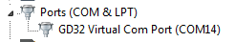

Open the Device Manager, and then double click on the “Ports” to display the driver (GD32 Virtual Com Port) and right click on the driver to open PROPERTIES. This will display the details of the driver, and under Port Settings update the “Bits per second” to 128,000 for faster read and write to the radio.

Note: Before you start any programming work read the current file from the radio into your PC so you have a baseline and something to start with.

STEP 1 – TALK GROUP (DIGITAL CONTACT) LIST

The AT-D868UV program looks like an excel spreadsheet once opened, and the left side defines the many aspects of programming. Open the DIGITAL CONTACT Talk Group tab on the left side and double click on the first line (Line No. 1). The Digital Contact List typically contains the DMR Talk Groups which the user may want to use.
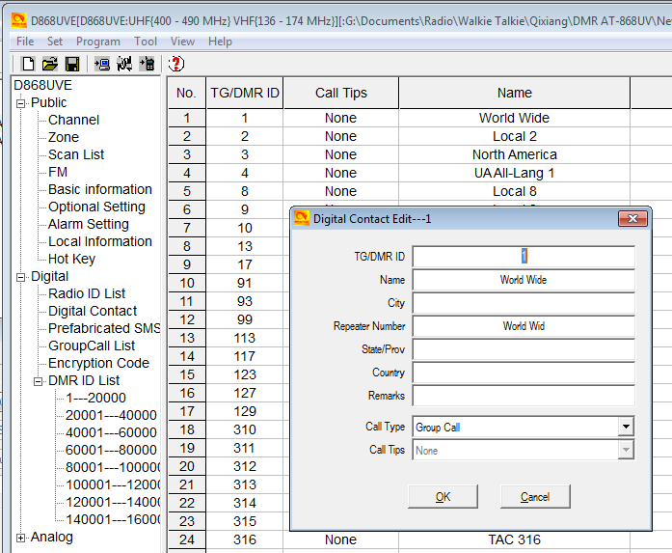

Start to program all applicable DMR Talk Groups (TG uses Group Call) you which to monitor or talk on. This list of Talk Groups may include up to 100+ different groups. A list of world wide Talk Groups can be found at http://www.dmr-marc.net/

The Talk Group list can also be generated by exporting the original radio Digital Contacts Talk Groups and then addint to that list in an excel format. In the Programming Software there is import and export features in the taskbar – open the TOOL and do an “export”. This opens up a new screen where you click on “Digital Contact”. A new screen shows up where you define where to save the list on your PC.
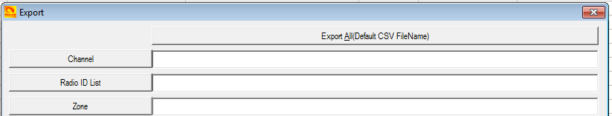

In the .csv format you can paste all or your required Talk Groups from the DMR-MARC website into the spread sheet. You get the format from the original radio Codeplug you just exported.
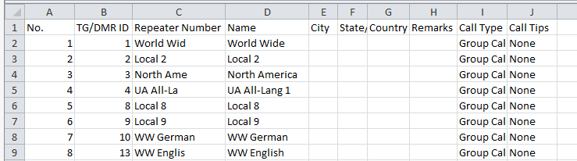

Once all TG’s are entered, the Contact List should be “imported” back into the Programming Software the same way you exported the file. Click on TOOLS, and then “import” and in the new window click on Digital Contacts and select the .csv file you want imported.
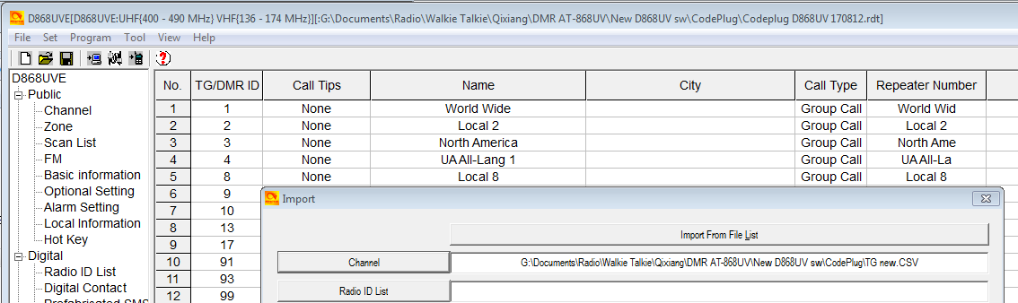

STEP 2 - DMR ID LIST
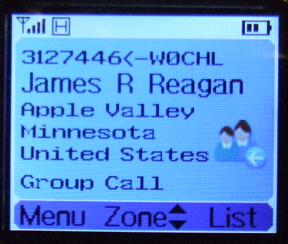
The next step is to fill the radio with all possible contacts you may ever encounter. By doing this, the radio will for each contact you make display the name, DMR ID, Callsign etc. of the individual you are connected with. The DMR-MARK list is steadily growing and you may have to pare it down to your needs.

The Contact List is a “look-up” table for the radio to display all the details of the contacted person instead of only the DMR ID number. Individual entries (updates) can be made as shown below, but would be very time consuming when creating the initial list.
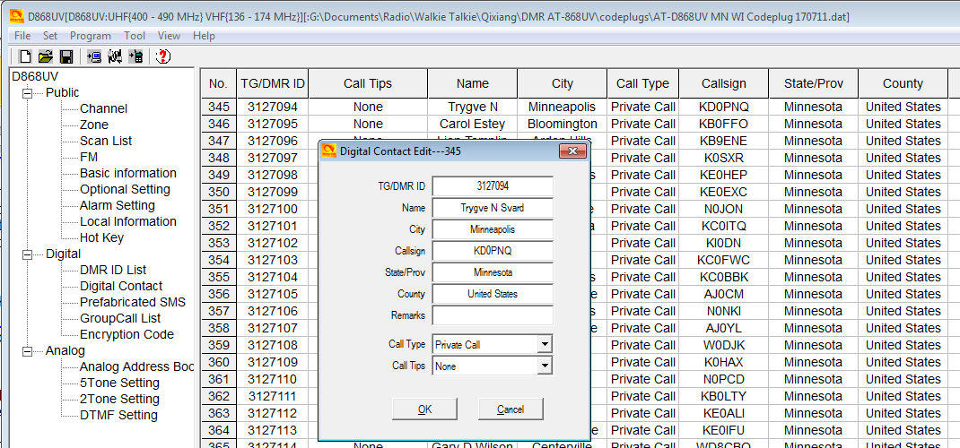

A master list of DMR contacts is available at the DMR-MARK website:
http://www.dmr-marc.net/cgi-bin/trbo-database/datadump.cgi
This database of contacts can be directly used for DMR ID’s and imported into the radio as required. Download the list and open it up as an excel spreadsheet. From the DMR database, in the .csv spreadsheet, select the country, the DMR ID’s you want to copy over to your radio as shown below (note: you may have to change the DMR database from a .cgi file type to a .csv file type to be able to use it).
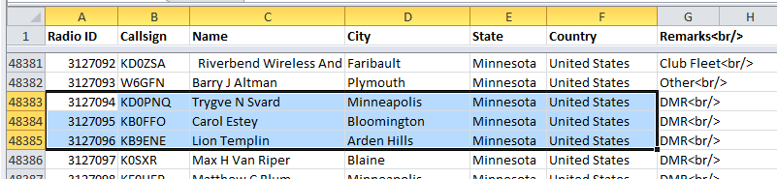

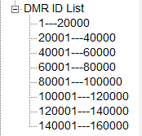
In the Programming Software open the TOOL and do an “export”. This opens up a new screen where you click on “DMR ID List” and on the second screen select where you want to save it on your PC. This list is divided in sections to accommodate up to 160,000 ID’s. So if your list you work in the .csv format is more than 20,000 names, when loaded into the radio, they will split up and be distributed between the several lists in the radio.

So now that you have both the DMR database and the radio original database open, copy the list of DMR ID’s you want from the DMR database into the radio .csv file. Then back to the TOOL menu, and “import” so you can import the entire .csv DMR ID list into the radio. Note: You have to enter “Private Call” in all the CALL TYPE columns of the radio .csv database before loading it into the radio. The No. column can be left blank.

This is how it looks before being loaded into the radio
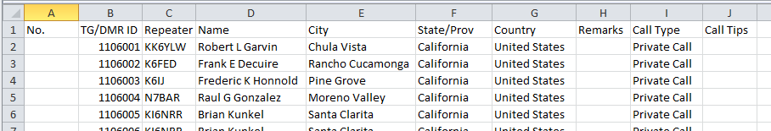

Once loaded into the radio, this is what it looks like

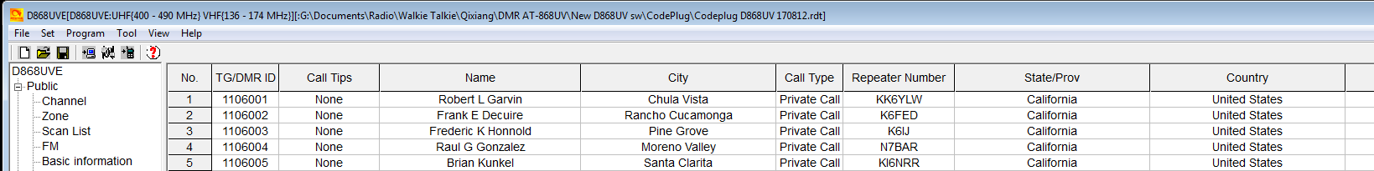

After you have created the Contact List in the radio Programming software, please save it on your PC so that you do not have to re-do this step. Depending on the size of the Contact list, it may take some time to load and read with your PC.

STEP 3 - RADIO ID LIST (Multiple Radio ID’s)

The AT-D868UV radio will allow multiple DMR Radio ID numbers to be used with the radio. This feature will allow one radio to be used for example as a Commercial Radio with its own DMR ID, and at the same time also be used as an Amateur radio with another DMR ID. Double click on a line and enter the data in the separate window. Click “OK” when done to save the data you entered.

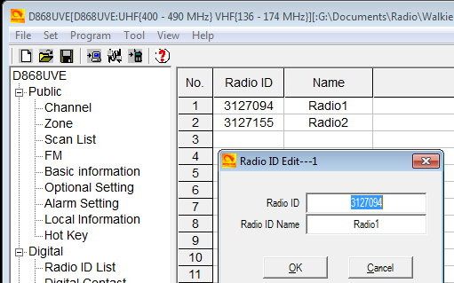
The multiple DMR ID numbers will later show up when programming the various frequencies used by the radio. So the radio can be used on multiple types of networks and be defined as appropriate for each network – Government, Commercial, and/or Amateur.

NOTE: If you download a CodePlug from the Internet for your radio, you must enter your DMR ID as per above before you load this CodePlug into the radio.

STEP 4 - SCAN LIST

Typically a scan list is created with one ‘channel’ for each repeater on slot 1, and one for the slot 2 channel. Initially just create an ‘empty’ scan list (with a name) to use during the channel creation step. Create the Scan list name that relates to your set of channels. In the Scan List menu, click on line No. 1 and open the Scan Edit window.
NOTE: A channel number refer to the Channel Matrix (excel format) number No. to the very left of the matrix – there you can reference the DMR Talk Group for a channel.

Scan List Name: Name it so it relates to the scan channels
Available Channels: Will list the channels you create
Scan Channel Memb.: Move over the channels you need scanned to this area
Scan Mode: Select On or Off
Priority Channel 1:
Priority Channel 2:
Revert Channel:
Look Back Time A:
Look Back Time B:
Dropout Delay Time:
Dwell Time:

Once all done, click on “OK” to save.

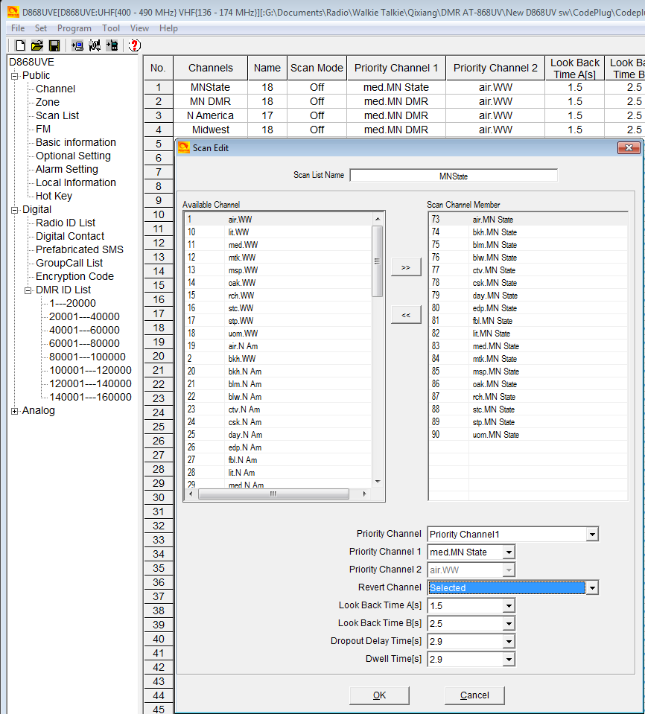

STEP 4 - ZONE LIST CREATION

Create a ‘Zone’ name (that relates to the name of the scan list in the step above) and leave empty for the time being. Creating a ‘Zone’ allows you to put your configured ‘channels’ into logical groups. You can use the same ‘name’ for these (as your Scan List names) to help you keep things straight in your mind, they are in two different sections, so there is no conflict. You will need to create a zone in order to select the group of channels you will be adding. Naming choice is up to you, but most ‘Zones’ have a limit of 16 channels. You can name each zone by the geographical location or any other name you wish. Add your channels in the order you wish them to be accessed by the channel select knob or menu selection. You may wish to use a name for your zones that relates to its ‘Scan Lists’.

In the Zone menu, click on Line No.1 to open the Zone Edit window.
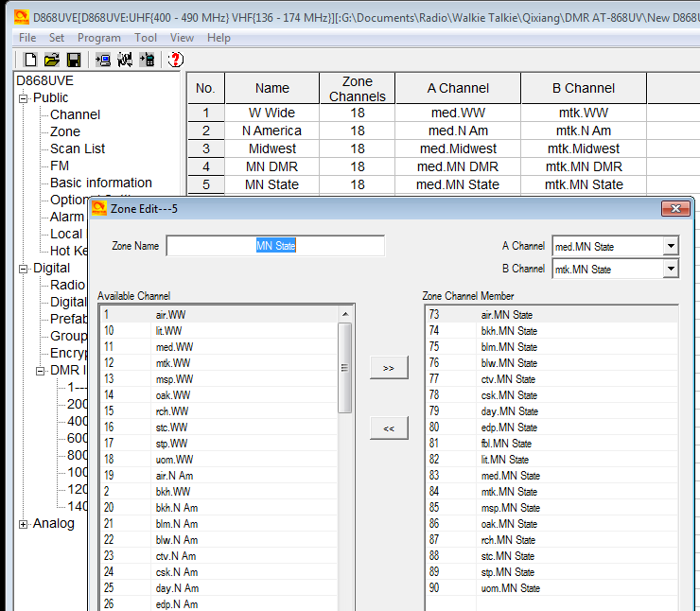

The above sample is scanning the same channel but from several different repeaters so that when driving around the city there is always an available connection. Other set-ups for scanning uses one repeater and scans all programmed Talk Groups on that repeater.

A Channel: The channel the radio starts up with for channel A
B Channel: The channel the radio starts up with for channel B

STEP 5 - CHANNEL – FREQUENCY SET-UP

The AT-D868UV offers programming of 4,000 channels for UHF and VHF. To start double click on the first line No.1 to open the Channel Information programming window for that channel:

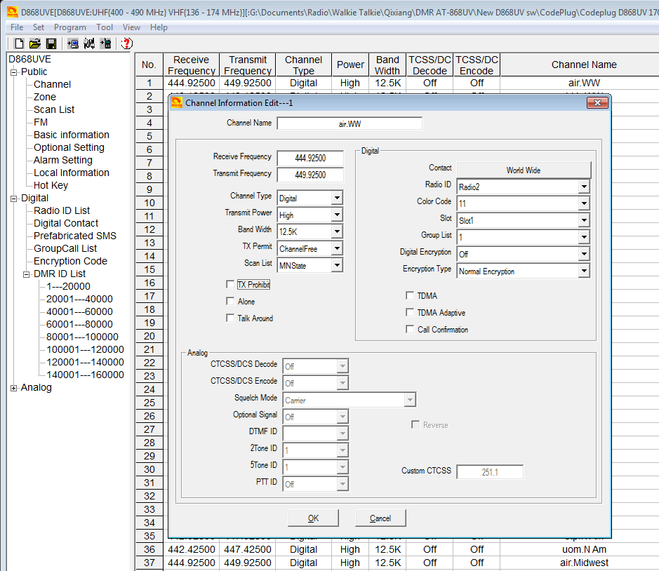

The Channel Information Edit window contains several options which will be explained below:

Channel Name: the name of the channel (typically name of repeater and TG)
Receive Freq.: the VHF or UHF frequency
Transmit Freq.: the VHF or UHF frequency
Channel Type: Select Analog, Digital, Mixed Analog or Mixed Digital
Transmit Power: Select one of four levels 6W/2.5W/1W/0.5W
Wide Narrow: Select the bandwidth of transmit
TX Permit: Select type of transmit function – typically ColorCode
Scan List: Select which Scan List this frequency belongs to
TX Prohibit: Check if the frequency is a listening channel only
Alone: Check if the “alone” emergency function should be allowed
Talk Around : Check if the TX and RX frequency should be the same

Digital
Contact: Select the Talk Group this frequency belongs to
DMR/Radio ID: Select which of the DMR ID’s to use for this channel
Color Code: Select which CC is related with this channel
Slot: Select which slot (1 or 2) applies to this “Contact”
Group List: Once programmed, select group list for this channel
Digital Encryption: Select if Off or which number to use
Encryption Type: Select which type to use.
TDMA: Check if xxxxxxxxxxx?
TDMA Adaptive: Check if xxxxxxxxxx?
Call Confirmation: Check if xxxxxxxx?
Analog
CTCSS/DCS Decode Select Off or CTCSS or DCS and tone frequency
CTCSS/DCS Encode Select Off or CTCSS or DCS and tone frequency
Squelch Mode: Select how to use the squelch
Optional Signal: Select Off, DTFM, 2Tone or 5Tone
DTFM ID: Select DTFM ID
2Tone ID: Select 2 Tone ID
5Tone ID: Select 5 Tone ID
PTT ID: Select off, at start, at end or both
Custom CTCSS: Enter value when requiring a custom CTCSS tone

Once completely filled in, click OK to save this Channel. There is also an option to first “export” the channel data into a .csv file, and then work the entry of most data in the excel format. Then save it and “import” back into the codeplug. For large channel data entries, this may be the easiest method where copy and paste function will allow easier generation of a lot of channels.

The channel set-up can also be created by first exporting the original channel set-up in the radio, and then as a .csv excel file edit, copy and paste as many channels and frequencies you need. As each repeater being programmed may have the same Talk Groups, working all of this in a excel format and then importing it all back into the radio is the most efficient method of building a large channel database for the radio.

Note: working the .csv file for channels, the No. column either should be empty, or show sequential numbers starting with 1 for channel 1, 2 for channel 2 etc.
STEP 6 - OPTIONAL SETTING

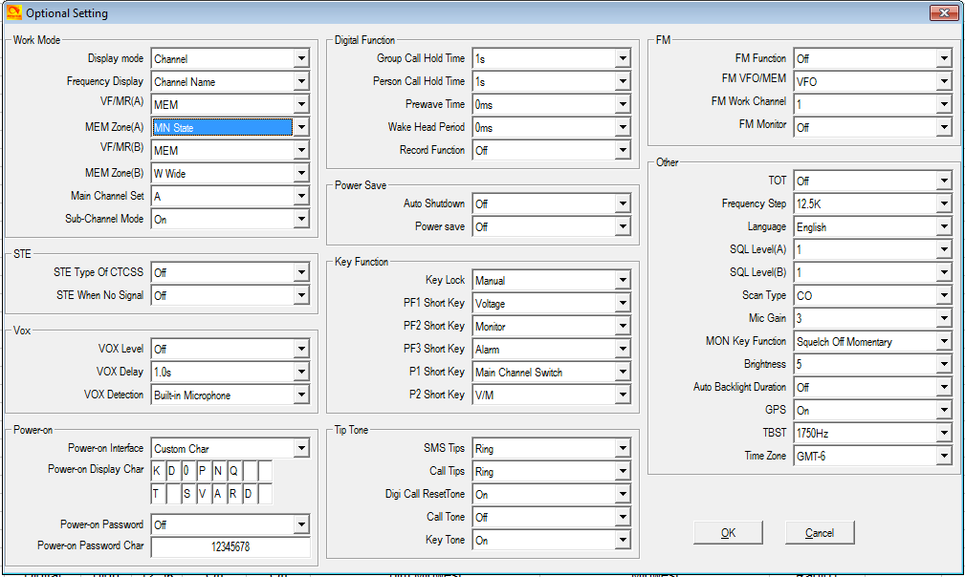
The AT-D868UV radio basic configuration set-up is done in the Optional Setting window.

Once the Optional Setting window is open, there are several sub-sections to program.

Work Mode

Display Mode: Defines what the radio display will show when in receive mode
Frequency Display: Defines if the display shows frequency or channel number
VFO/MEM A: Select VFO or MEM for the “A” upper channel
MEM Zone A: Selects any of the programmed Talk Groups
VFO/MEM B: Select VFO or MEM for the “B” lower channel
MEM Zone B: Selects any of the programmed Talk Groups
Main Channel Set: Select the “A” or “B” channel to become the main channel
Sub-Channel Mode: Select off if only the “A” channel will be used or both

SQUELCH TAIL ELIMINATE (STE)

STE Type CTCSS: Off, Silent or a selected setting
STE When No Signal: Select Off, 55.2 Hz or 259.2 Hz

VOX

VOX Level : Select off or 1 to 3
VOX Delay: Select how many seconds of delay
VOX Detection: Select built-in mic or external mic or both

Power On

Power-on Interface: Select custom display or radio standard display
Power-on Display Char.: Enter your unique display for start-up
Power-on Password: Select on or off
Power-on Password Ch.: Write in keyboard characters to unlock the radio

Digital Function

Group Call Hold Time: Select hang time for a Group Call
Person Call Hold Time: Select hang time for a Private Call
Prewave Time: Select the time to wake-up the radio from a power save
Wake Head Period: Select the time for the preamble
Record Function: Select on or off for the internal record function

Power Save

Auto Shutdown: Select off or minutes before auto shut-down
Power Save: Select off or on

Key Functions

Key Lock: Select Manual or Auto key lock function
PF1 Short Key: Select from several functions for the radio key below PTT
PF2 Short Key: Select from several functions for the radio key 2 below PTT
PF3 Short Key: Select from several functions for the orange radio key
P1 Short Key: Select from several functions for the P1 radio key
P2 Short Key: Select from several functions for the P2 radio key

FM

FM Function: Turn on or off the FM radio
FM VFO/MEM: Select VFO or Memory
FM Work Channel: Select the FM channel to listen to (after set-up done)
FM Monitor: When in FM mode select on if the radio shall receive calls

Other

TOT: Max Total Time of Transmit
Frequency Step: In VFO mode, selects the frequency steps
Language: Select language for the programming software
SQL Level A: Set the squelch level for the “up” channel – set at 2
SQL Level B: Set the squelch level for the “down” channel – set at 2
Scan Type: Select TO – 5 sec stop, CO – 2 sec stop or SE stops scan
Mic Gain: Allows increasing the mic sensitivity
MON Key Function: Set to define the function of the side key for “Monitor”
Brightness: Sets the display brightness – 5 is the brightest
Auto Backlight Duration: Sets the time the display is on or off for always on
GPS: Set On or off
TBST: Tone Pulse Freq. Selection for opening certain repeaters
Time Zone: Set the GMT time zone for the radio

Once all the parameters have been programmed, click on “OK” to save what you have programmed.

POPULATE YOUR SCAN LIST

Go back to your Scan List, add the ‘ON’ channels for slot 1 and 2 to this list from the just created group of channels. You may also implement the alternative method, understanding the limitations.

POPULATE THE ZONE LIST WITH CHANNELS

Go back to the Zone List you previously created and add in the first 16 channels of the most recent group you added. Most radios can only have 16 channels in a Zone, so pick the ones you want. If you need more, then you create another Zone List and add the ones missing. If the Talk Group is in the less used second zone, you will need to change zones and channel to reply (unless you set a sufficient delay in scanning). With this method, your scan list will scan all active talk groups on any channel, then you rotate the channel selector to that talk group to respond.

CREATE ANALOG ZONE AND CHANNELS

Add a zone for your analog channels, then add each repeater as a channel. Name your zone by its function or geography (choice is yours). Optionally you can also create scan lists for your analog channels and assign a scan list to a group of channels or an entire zone.

ANALOG ADDRESS BOOK

The radio allows a set of addresses for the Analog mode. Open the Analog Address Book and click on the first line to open the Analog Address Book Edit window.

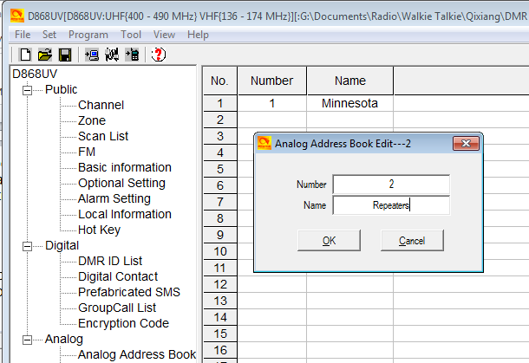

The Call ID reference the DTMF or 5Tone number programmed under its menu

PREFABRICATED SMS

The radio has a function to send SMS messages from your radio to other Digital Contacts. There is an opportunity to create advanced SMS messages and have them stored in the radio. Open the Prefabricated SMS window, and click on the first line to open the Prefabricated SMS Edit window.

Here you can program SMS messages and store in the radio – see below.

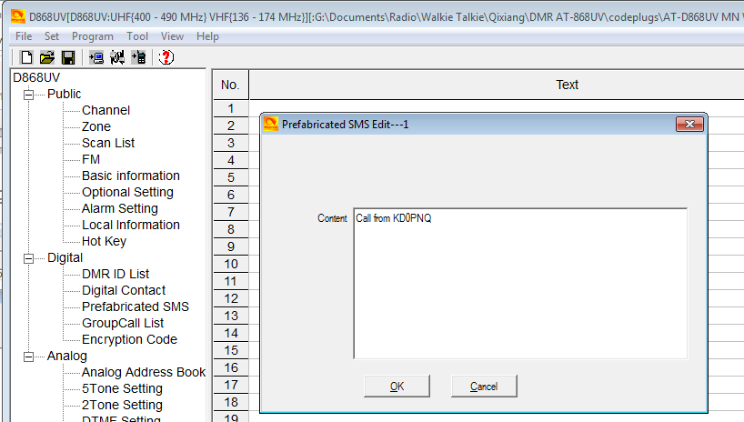

GROUP CALL LIST

A common function for a DMR Radio is to send Group Calls. The set-up of Group Calls , open up the Group Call List Edit window and create your Group Call List Members.

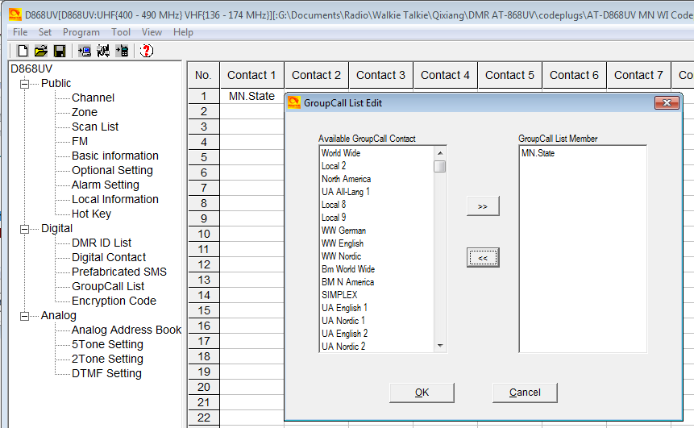

ALARM SETTING

The radio offers a comprehensive alarm system to protect the user of the radio under several conditions. Open the Alarm Setting to gain access to the Emergency Information Edit window.

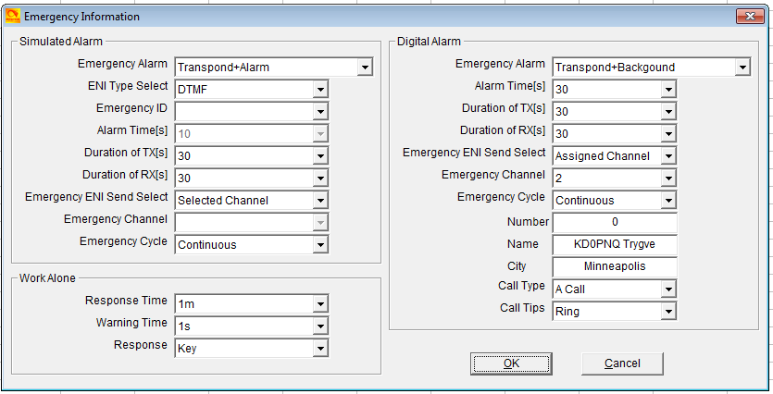
Simulated Alarm

Emergency Alarm: Select from Alarm, Transpond + Background, Transpond + Alarm, or Both
ENI Type Selected: Select from None, DTMF or 5Tone
Emergency ID:
Alarm Times: Select after what time the alarm should be initiated
Duration of TX: Select the duration of the Alarm transmission
Duration of RX: Select the duration of listening mode after an alarm reset
Emergency ENI: Select which channel the Alarm should be sent out on
Emergency Ch.: Select which channel to use
Emergency Cycle: Select Continuous or a time
NOTE: A channel is the No. on the Channel Menu line for the selected frequency.

Work Alone

Response Time: Select the time for the radio to respond to an Alarm trigger
Warning Time: Select the duration if a warning transmission
Response: Select Key or Voice for a response to reset

Digital Alarm

Emergency Alarm: Select one of 4 options for how to initiate an Alarm
Alarm Time: Select after what time to initiate the Alarm
Duration of TX: Select the duration of the Alarm transmission
Duration of RX: Select the duration of listening mode after an alarm reset
Emergency ENI: Select which channel the Alarm should be sent out on
Emergency Ch.: Select which channel to use
Emergency Cycle: Select Continuous or a time
Number: Channel number from the Channel Menu No. line
Name: Enter the name and license number you want transmitted.
City: Enter the location of your position to be transmitted
Call Type: Select the type of call you need for an Alarm
Call Tips: Select how you want the alarm to respond.

Enter OK to save.

LOCAL INFORMATION

Displays the COM port information

HOT KEY

The Hot Key programming offers 3 sub-windows within the Hot Key Edit window.

Analog Quick Call

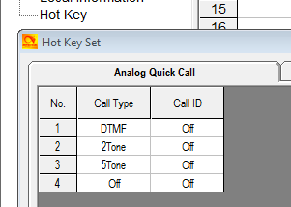

The Call ID refer to the DTFM, 2Tone or 5 Tone set up under separate menu

State Information

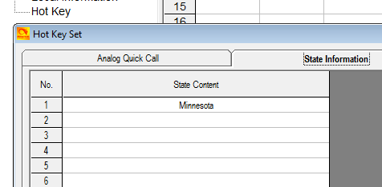

Hot Key

The Hot Key Set window allow …

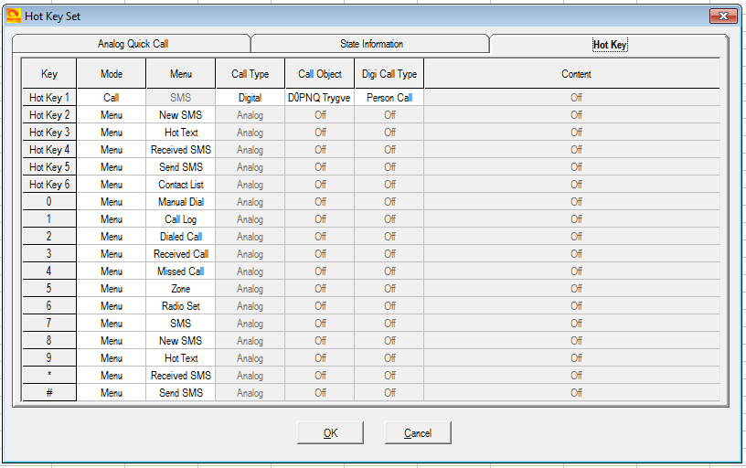

ANALOG PROGRAMMING

The programming of Analog channels are done the same way as for the digital channels. Analog and digital channels can be mixed, but will be easier to find if programmed as a separate group at the end of all digital DMR channels. Exporting and working all this in the .csv format will allow to sort the channels before loading into the radio, so that the digital channels appear first, and the analog following rather than intermixed.

If you by means of this Guide feel confident to program digital channels, entering your analog channels should be very easy.
FINAL STEP - WRITE YOUR CODEPLUG TO YOUR RADIO

The AT-D868UV radio comes with a special programming cable. This cable requires the computer to find a driver so that it will work correctly – most computers will find this driver automatically when inserted into the USB connector and radio for the first time. Per note on page 1 please update the read and write speed of the driver.

Write the file to your radio. Save the file to your PC with a name that you will remember. You may wish to use version numbers in your file naming to help you with progressive updates. At some point you may ‘break’ your codeplug by setting something differently and this may affect the radio operation. It helps to be able to ‘go back’ to an earlier working version. Some Codeplug Programming Software (CPS) may also require that you update the clock in the radio by another function, be sure to do this if you want an accurate time display!

AT-D868UV RADIO TOTAL SYSTEM RESET

If the AT D868UV radio becomes un-operative, there is a solution to reset the entire radio. This is not recommended if the radio operates ok, but can become a final solution for a major problem.

To reset the radio, power it on while holding the PTT and the PF1 button below the
PTT at the same time. The radio will start up with a note on the display stating MCU Reset, Please Wait – and do not turn the radio off while it restarts.

After a re-start the radio will display the setting of the date and the time. Use the up-down key to set the current year. Move to the month by pushing the P1 key. Set the month, and use the P1 key to move forward each step. Once done, click the Menu key to save the date and time.

You may now see the Chinese language. If it starts with Chinese, click Menu, scroll down to the grey cogwheel globe and click Menu, click Menu 1 more time and scroll down to item #8 and click Menu and select English.

The codeplug has also been replaced as part of the system re-set, so you need to re-load your codeplug into the radio to make it work the way it should.

